EMERGENCY REPORTING SYSTEM

IBM WATSON BUILD 2018 SUBMISSION


Dated: 17TH July 2018

Version 1.0

Business Plan for an Emergency Reporting System (ERS)

Author: Vascon Solutions Limited

Submission Date:
17/07/2018

Big Idea

Emergency Reporting System (ERS) is an application built on IBM Watson APIs and other related services to enable seamless and analytics driven interactions between users and emergency responders in cases of emergencies.

Our Solution

Historically, Emergency Response and data collation in Africa have occurred based on last mile reporting and more recently, GSM phone call-ins into a control center. This has resulted in Emergency Response in Africa being sub-optimally administered and a bane for Governments all over the continent. With the rise in terrorism, gender based violence and natural disasters like Flooding of which killed over 1000 people last year in Sierra Leone, there is without doubt an urgent need for an improvement in emergency response across the continent and all over the world.
Considering the world at large, conventional means of contacting emergency responders have been effective but have proven to be unreliable in situations where the callers outnumber the contact agents. Hurricane Harvey in Houston, Texas lends credence to the above. For example, NY Times reported that many residents had trouble getting through to 911 and many said calls to officials for help went unanswered.
With the recent advancement in mobile communication, several emergency responders and individual bodies have had an impact on the development of emergency reporting applications as another means of contacting emergency responders. But reporting emergencies with a greater number of these applications, is done by filling out web forms which can be time consuming and mundane for users.

Our solution therefore leverages on Watsons APIs to enable seamless and analytics driven interactions through a conversational user interface. This will give users a superior user experience and convenience when reporting emergencies.
Offerings in detail include:
- Virtual Agent: The term “virtual agent” is used to better explain the core function of our solution which is built on Watson Assistant. It is trained to not only understand various types of emergencies but to also provide first aid instructions until the responders get to the scene. The user will also be provided with frequent updates on the status of the case once dispatched to the emergency responders.

- Safety Advisor: The safety advisor is feature built on Watson Analytics along with the weather channel. It provides the user with response to common emergency FAQ's and safety advise for different locations in town with information like weather updates, trending activities (e.g. active crime scene) on-demand.

- Language Translator: Our solution includes a combined API model to integrate Watson conversation Service with Language Translator Service. When reporters choose French or Spanish as a reporting language, the front end API provided to them is Language Translator. The output of this API will be the input of the text API service – Conversation, again the result of Watson Conversation service will become the input of Language Translator so that the reporter can be responded with their language.

- Analytics: With the vast amount of data collected and stored, our solution taps into IBM’s Watson Analytics service to gain greater and faster insight through visualization on the admin page. Admin users can also monitor customer sentiments and comments on emergencies from various social media sources.

- Speech to Text: In a situation where users can’t type, their audio and voice can be easily converted to text with Watsons speech to text service which is used in this solution.

- Geo-location feature: With this feature, users geo-coordinates are detected and sent to Google Maps to get their exact location.

- Mass Alert notification: This feature allows for the admin to compose alert messages and send to users when emergencies occur.

Solution Architecture

By enabling Watson APIs and third party APIs, our ERS application provides two main user interfaces – Mobile application and an Administrative web view. The mobile component also provides two categories, one for the user reporting the emergency and the other for the responders that are on the field and receive these emergency reports.

User Mobile Application:
This application is used by the user to raise emergency reports. The interface has been optimized to reduce the number of steps that the user undergoes to report any emergency to at most 4 steps all under 30 seconds and yet be as precise as possible. The interface uses Watson Conversation ability to understand Natural Language processing to facilitate this speed of interaction. For better user experience, the home page of our solution shows top three emergency types as buttons which each trigger an action that sends a quick report to the virtual agent. The emergency type shown on each users application will differ based on their geographic location, gender and age. Insight gained on data analyzed will be used by our solution in determining what type of common emergencies to display on the home page of each user.
This application makes use of the following IBM services:
• Watson Conversation
• Watson Speech-to-text
• Watson Translator
• Discovery
• Watson Analytics
• Weather channel.

Emergency Responder Mobile Application:
This application is like the Swiss army knife of responder applications, because of the following functions, it enables the on-field responders to receive new emergencies, get directions to those emergency sites, confirm the emergency when they arrive, request for back-up, provide cause updates either by typing or simply by recording a voice note. This application makes use of the following IBM service: Watson speech to text.
There is also a conversation interface that can easily and quickly allow the responder access to vital information like the closest water hydrant, general hospital and other emergency locations.

Emergency Administrative Web view:
This is used by the control center to track and manage emergency reports as they come up. The view is mostly a Map View that is used to display a dashboard of reports, the view is actionable in a way that an admin user can click a case on the map and interact with responder that has been assigned the case. The administrative web view makes use of the following IBM service: Data science experience. Also the admin can have access to conversation that can easily and
quickly provide access to vital information like the closest water hydrant, general hospital, ER consultants and other emergency locations.

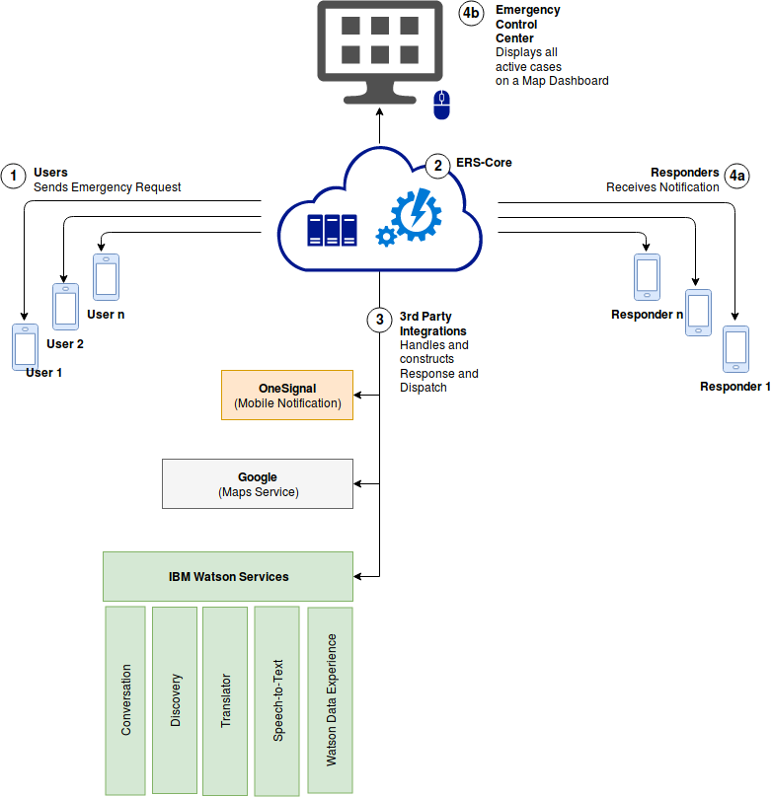

Target Market

For ERS, we have identified three different players in need of its capabilities & offerings namely Emergency Management Agencies, Real Estate companies and school campuses.

Emergency Management Agencies: Within the government agencies are Disaster and relief management agencies such as the Police force, Federal road safety commission & fire brigade. Decisions on purchases are made within the agencies but are largely influenced by state and federal governments. ERS will play a large role in aiding response to emergencies by communicating seamlessly with citizens and it would also cater the need of government agencies receiving the reports directly.
Real Estate Companies: Most real estate companies in our target market are responsible not only for management of estate facilities but the protection of lives and properties of its residents. Virtual ERS will assist in the management of emergency reports within the estates.
School Campuses: Schools with large campuses and over 5000 students.

Market Needs

Emergency reporting is a very sensitive aspect of emergency management because when complete & accurate details on emergencies are not known it can hinder the entire process and can eventually lead disasters.
For players in our target market, there is a need for another channel for reporting emergencies which is efficient, user friendly and can provide greater and faster insights to data at the control data.

Competition

The only competitor with an established presence in our home country, Nigeria is a small sized player called Smart Police. Smart Police is a mobile application designed for users to send report of incidents (Rapes, robberies, assault, and theft) to the Nigerian police. Since its launch in January 2017, it’s had 10,000-50,000 installs out of about 15.5 million of mobile phone users clearly indicating the lack of awareness of citizens on the application.
Smart police capabilities include a reporting module for users to describe the incident and their location of which the offerings of ERS far outweigh.
For quick entry into this market, Virtual ERS will leverage on its wide range of offerings and infallible commitment to provide optimum services to its customers. Also, our go-to-market strategy involves an aggressive marketing strategy to raise awareness on virtual ERS of which we intend to carry out without any additional cost to our customers for six months.

Team

VASCON Solutions Limited [VAS] is a technology company focused on Value Added Solutions Delivery in the Enterprise space and Information Technology Consulting. VAS Limited draws from an experienced base of personnel whilst maintaining a personalized form of business liaison. The ultimate in consultation, skills diversity and adaptability to meet client expectations are the core strengths of VASCON Solutions Limited
As a company, we are positioned as key Solutions consultants, developing strategic relationships with core technology providers. It is our vision to work with our clients on the basis of extensive knowledge transfer and we are happy to begin this process by sharing our experience and in-depth knowledge of Software Development, Operation support System (OSS) Application, Customer Relationship Management (CRM), Supply Chain Management, Enterprise applications, Portal technology, Voice and Data technologies.
Our solutions span a range of industry standards and platforms targeted at adding immediate value to our clients which range from Oil and Gas, Manufacturing, Finance and Telecommunications providers in Africa. We are positioned as key solution consultants, programmers, software developers and system integrators and we have partnered with IBM for over x years.

Sales and Marketing

Summary of Routes-to-Market Strategy
For our go-to-market strategy, we’ll be combining two channels- Online and Direct Sales.
Online Sales:
In order to reach a wider audience, an easy to use and reliable website will be created for ERS. This website will display information on its offerings/capabilities and contact information on how to subscribe.
We also intend to create a customer database for potential customers and then send out direct emails to each customer.
Direct Sales:
After carrying out the online sales strategy, we would sell directly to the target market by meeting with the decision makers and discussing its capabilities/offerings and being open to feedback from the customers.

Risk Assessment

Possible risks which can affect the virtual ERS include:
- Improper use of the system: Improper use of ERS can lead to loss of vital information, government agencies must be trained on use of the system.

- New competitors entering the market: ERS will leverage on its offerings, capabilities and its free digital marketing services for 6 months to each subscriber to gain competitive edge.

Milestones

Execution: | Description/Status | Due Dates | Metrics/ | Owners
Critical Tasks, | Specific actions, issues |  | KPIs
Dependencies
Development of ERS | Development with Watson APIs (Conversation, Speech Translator, Insights) by programmers. | 2 months after project Start date | Agile process metrics, security,  Production metrics. | Programmers
Development of Website for Online Sales | Development by programmers with PHP, CSS, HTML | 2 weeks after Development of ERS | Production metrics | Programmers
Go-to market (Online Sales) | B2G Online Marketing | Commencement when website is launched | Leads & Opportunities | Sales & Digital marketing team
Go-to market (Direct Sales) | Meeting with clients one on one | 1 month after online Sales | Leads & Opportunities | Sales Team

